## Task No: 1

**AIM: Write a JAVA program to display default value of all primitive data types of JAVA.**

## PROGRAM:

class LabTask1

{

static int a; static float b; static char c;

static long d;

static double e;

static boolean f;

static byte g;

static short h;

static String i;

public static void main(String args[])

{

System.out.println(“Default values of Primitive Datatypes”); System.out.println(“Default values of int=” +a);

System.out.println(“Default values of float=” +b); System.out.println(“Default values of char=” +c); System.out.println(“Default values of long=” +d); System.out.println(“Default values of double=” +e); System.out.println(“Default values of

boolean=” +f);

System.out.println(“Default values of byte=” +g);

System.out.println(“Default values of short=” +h);

System.out.println(“Default values of String=” +i);

}

}

## Task No: 2

**AIM: Write a JAVA program that displays the roots of a quadratic equation ax2+bx+c=0. Calculate the discriminate D and basing on the value of D, describe the nature of roots.**

## PROGRAM:

// LabTask2.java

import java.util.Scanner; public class LabTask2

{

public static void main(String args[]) {

Scanner input=new Scanner(System.in);

System.out.print("Enter value of a:");

double a=input.nextDouble(); System.out.print("Enter value of b:"); double b=input.nextDouble(); System.out.print("Enter value of c:"); double c=input.nextDouble();

double d=b*b-4.0*a*c; if (d>0.0)

{

double x1=(-b+Math.pow(d,0.5))/(2.0*a);

double x2=(-b-Math.pow(d,0.5))/(2.0*a);

System.out.println("THE ROOTS ARE "+x1+" AND "+x2);

}

else if (d==0.0)

{

double x1=-b/(2.0*a);

System.out.println("THE ROOTS ARE "+x1+" AND "+x2);

}

else if (d==0.0)

{

System.out.println("THE ROOTS ARE "+x1+" AND "+x2);

}

System.out.println("THE ROOTS ARE "+x1+" AND "+x2);

}

else if (d==0.0)

{

double x1=-b/(2.0*a);

System.out.println("ROOTS ARE REAL AND EQUAL"); System.out.println("The roots are"+x1);

}

else

{

System.out.println("IMAGINARY ROOTS");

}

}

}

## Task No: 3

**AIM: Write a JAVA program to display the Fibonacci sequence.**

## PROGRAM:

//LabTask 3

import java.util.Scanner; public class LabTask3

{

Int a=0,b=1,s;

Public static void main String args[])

{

LabTask3 j=new LabTask3(); Scanner l=new Scanner(System.in); System.out.println(“Enter range:”); int range =l.nextInt();

int i;

System.out.println(“Fibonacci”); System.out.println(j.a); System.out.println(j.b); for(i=3;i<=range;i++)

{

j.s=j.a+j.b;

System.out.println(j.s);

* 1. =j.b;
  2. =j.s;

}

}

}

## Task No: 4

**AIM: Write a JAVA program give example for command line arguments.**

## PROGRAM:

// LabTask4.java public class LabTask4

{

public static void main(String p[])

{

int x=Integer.parseInt(p[0]);

int y=Integer.parseInt(p[1]);

int sum=x+y;

System.out.println("Sum of two numbers is:"+sum);

}

}

## Lab Task No: 5

**AIM: Write a JAVA program to give the example for ‘this’**

## operator. And also use ‘this’ keyword as return statement. PROGRAM:

//LabTask5

import java.util.Scanner; class BigSmall

{

int a,b;

Biggest SetValues()

{

Scanner sc= new Scanner(System.in); System.out.print("Enter 'a' value: "); int a=sc.nextInt(); System.out.print("Enter 'b' value: "); int b=sc.nextInt();

this.a=a; this.b=b; return this;

}

void display()

{

if(a>b)

{

System.out.print("a is big");

}

else{

System.out.print(“b is big");

}

}

public static void main(String args[]){ BigSmall d = new BigSmall(); d=d.SetValues();

d.display();

}

}

## Lab Task No: 6

**AIM: Write a JAVA program to demonstrate static variables, methods, and blocks.**

## PROGRAM:

// LabTask6.java public class LabTask6{

static String s="Hello"; static int x=60;

static int y;

static void fun(int z){

System.out.println("s: "+s); System.out.println("x= "+x); System.out.println("y= "+y); System.out.println("z= "+z);

}

static{

System.out.println("static block is invoked"); y=x-20;

}

public static void main(String args[])

{

fun(10);

}

}

## Lab Task No: 7

**AIM: Write a JAVA program to search for an element in a given list of elements (linear search).**

## PROGRAM:

// LabTask7.java import java.util.Scanner;

public class LabTask7

{

public static void main(String args[])

{

int a[],n,search,i;

Scanner sc=new Scanner(System.in); System.out.println("Enter number of elements: ");

n=sc.nextInt(); a=new int[n];

System.out.println("Enter "+n+" elements: "); for(i=0;i<n;i++)

{

a[i]=sc.nextInt();

}

System.out.println("Enter the value to find: "); search=sc.nextInt();

for(i=0;i<n;i++)

{

if (a[i]==search)

{

System.out.println(search+" is found at location "+(i+1)); break;

}

}

if(i==n)

System.out.println(search+" is not found in array");

}

}

## Lab Task No: 8

**AIM: Write a JAVA program to search for an element in a given list of elements using binary search mechanism.**

## PROGRAM:

// LabTask8.java import java.util.Scanner; public class LabTask8

{

public static void binarySearch(int arr[],int first,int last,int search)

{

int mid=(first+last)/2; while(first<=last)

{

if(arr[mid]<search ) first=mid+1;

else if(arr[mid]==search)

{

System.out.println("Element "+search+" is found at position"+(mid+1)); break;

}

else

{

last=mid-1;

}

mid=(first+last)/2;

}

if(first>last)

System.out.println("Element is not found in array");

}

public static void main(String args[])

{

int arr[],n,search,i;

Scanner sc=new Scanner(System.in); System.out.println("Enter number of elements: ");

n=sc.nextInt(); arr=new int[n];

System.out.println("Enter "+n+" elements: "); for(i=0;i<n;i++)

arr[i]=sc.nextInt();

System.out.println("Enter the value to find: "); search=sc.nextInt();

int first=0; int last=n-1;

binarySearch(arr,first,last,search);

}

}

## Lab Task No: 9

**AIM: Write a JAVA program to sort given list of numbers. PROGRAM:**

//LabTask9.java import java.util.Scanner; public class LabTask9

{

public static void main(String args[])

{

Scanner sc=new Scanner(System.in); System.out.print("Enter array size:"); n=sc.nextInt();

int a[]=new int[n]; System.out.println("Enter the elements:"); for(int i=0;i<n;i++)

{

a[i]=sc.nextInt();

}

for(int i=0;i<n;i++)

{

for(int j=i+1;j<n;j++)

{

if(a[i]>a[j])

{

int temp = a[i];

a[i] = a[j];

a[j] = temp;

}

}

}

System.out.print("Sorting The No.s In Ascending Order:"); for(int i=0;i<n;i++)

System.out.print(a[i]+" ");

}

}

## Lab Task No: 10

**AIM: Write a JAVA program to sort an array of strings. PROGRAM:**

//LabTask10.java import java.util.Arrays; public class LabTask10

{

public static void main(String args[])

{

String[] Heroes={"Adolf Hitler","JosephStalin","VladimirPutin","Barack Obama","ElonMusk","Nicholas Tesla","SatyaNadella"};

//Arrays.sort(Heroes); int n=Heroes.length; for(int i=0;i<n;i++)

{

for(int j=i+1;j<n;j++)

{

if(Heroes[i].compareTo(Heroes[j])>0)

{

String temp=Heroes[i]; Heroes[i]=Heroes[j]; Heroes[j]=temp;

}

}

}

System.out.println(Arrays.toString(Heroes));

}

}

## Lab Task No: 11

**AIM: Write a JAVA program to check whether given string is palindrome or not.**

## PROGRAM:

//LabTask11.java import java.util.Scanner; public class LabTask11

{

public static void main(String args[])

{

String str,rev="";

Scanner sc=new Scanner(System.in); System.out.println("Enter the string: "); str=sc.nextLine();

int l=str.length(); for(int i=l-1;i>=0;i--){ rev=rev+str.charAt(i);

}

if(str.equals(rev))

System.out.println(str+" is a Palindrome"); else

System.out.println(str+" is not a Palindrome");

}

}

## Lab Task No: 12

**AIM: Write a JAVA program to determine the addition of two matrices.**

## PROGRAM:

//LabTask12.java import java.util.Scanner; public class LabTask12{

public static void main(String args[])

{

int x,y;

Scanner sc=new Scanner(System.in); System.out.println("Enter no.of rows of a matrix: "); x=sc.nextInt();

System.out.println("Enter no.of columns of a matrix: "); y=sc.nextInt();

int mat1[][]=new int[x][y];

int mat2[][]=new int[x][y];

int sum[][]=new int[x][y];

System.out.println("Enter elements of 1st matrix: "); for (int i=0;i<x;i++)

{

for(int j=0;j<y;j++) mat1[i][j]=sc.nextInt();

}

System.out.println("Enter elements of 2nd matrix: "); for(int i=0;i<x;i++)

{

for(int j=0;j<y;j++) mat2[i][j]=sc.nextInt();

}

for(int i=0;i<x;i++)

{

for(int j=0;j<y;j++) sum[i][j]=mat1[i][j]+mat2[i][j];

}

System.out.println("Addition of matrices: "); for(int i=0;i<x;i++)

{

for(int j=0;j<y;j++) System.out.print(sum[i][j]+"\t"); System.out.println(); System.out.println();

}

}

}

## Lab Task No: 13

**AIM: Write a JAVA program to determine multiplication of two matrices.**

## PROGRAM:

//LabTask13.java import java.util.Scanner; public class LabTask13{

public static void main(String args[])

{

int n;

Scanner sc=new Scanner(System.in); System.out.println("Enter base of matrices: "); n=sc.nextInt();

int mat1[][]=new int[n][n];

int mat2[][]=new int[n][n];

int mul[][]=new int[n][n];

System.out.println("Enter elements of 1st matrix: "); for (int i=0;i<n;i++)

{

for(int j=0;j<n;j++) mat1[i][j]=sc.nextInt();

}

System.out.println("Enter elements of 2nd matrix: "); for(int i=0;i<n;i++)

{

for(int j=0;j<n;j++) mat2[i][j]=sc.nextInt();

}

for(int i = 0; i < n; i++)

{

for(int j = 0; j < n; j++)

{

for(int k = 0; k < n; k++) mul[i][j]=mul[i][j]+mat1[i][k]*mat2[k][j];

}

}

System.out.println("Multiplication of matrices: ");for(int i=0;i<n;i++)

{

for(int j=0;j<n;j++) System.out.print(mul[i][j]+" "); System.out.println();

System.out.println();

}

}

}

## Lab Task No: 14

**AIM: Write a JAVA program for the following**

## Example for call by value.

1. **Example for call by reference.**

## PROGRAM:

//LabTask14a.java class LabTask14a

{

public static void main(String[] args)

{

int a=10; int b=20;

System.out.println("Before Swapping a =”+a+ “ and b=”+b);

swap(a,b);

System.out.println("value of a=” +a+ “ and b= "+b “after the call”);

}

public static void swap(int a,int b)

{

int temp=a; a=b; b=temp;

System.out.println(“After swapping a=” +a+ “ and b=”+b+);

}

}

## //LabTask14b.java

class LabTask14b

{

int a,b;

public static void change(LabTask14b r)

{

r.a=20;

r.b=10;

}

public static void main(String args[])

{

LabTask14b r=new LabTask14b(); r.a=10;

r.b=20;

System.out.println("Before changing..."); System.out.println("a="+r.a+",b="+r.b); change(r);

System.out.println("After changing.."); System.out.println("a="+r.a+",b="+r.b);

}

}

## Lab Task No: 15

**AIM: Write a JAVA program that illustrates simple inheritance.**

## PROGRAM:

//LabTask15.java

class Animal

{

void eat()

{

System.out.println(“eating…”);

}

class Dog extends Animal

{

void bark(){

System.out.println(“barking…”);

}

Public class LabTask15

{

public static void main(String args[])

{

Dog d=new Dog();

d.bark();

d.eat();

}

}

## Lab Task No: 16

**AIM: Write a JAVA program that illustrates multi-level inheritance.**

## PROGRAM:

//LabTask16.java class A

{

Int a=50,b=30;

}

Class B extends A

{

int c=80;

void add2(){

System.out.println(“addition”+(a+b));

}

}

Class C extends B

{

void add3(){

System.out.println(“addition is “+(a+b+c));

}

public static void main(String[] args)

{

C b1=new C();

b1.add3();

}

}

## Lab Task No: 17

**AIM: Write a JAVA program demonstrating the difference between method overloading and method overriding.**

## PROGRAM:

//LabTask17a.java

//Method Overloading class LabTask17a

{

public static void area(int l,int b)

{

System.out.println("Area of rectangle is "+(l*b));

}

public static void area(double r)

{

System.out.println("Area of circle is "+(Math.PI*r*r));

}

public static void main(String args[])

{

area(2,3);

area(2.0D);

area(22,24);

}

}

//Labtask17b.java

//Method Overriding class One

{

public void num(int a,int b)

{

System.out.println("Sum of "+a+" and "+b+"is" +(a+b));

}

}

class Two extends One

{

public void num(int a,int b)

{

System.out.println("Multiplication of "+a+" and "+b+ " is " +(a*b));

}

}

public class LabTask17b

{

public static void main(String args[])

{

Two t=new Two(); t.num(12,10);

t.num(3,3);

}

}

## Lab Task No: 18

**AIM: Write a JAVA program demonstrating the difference between method overloading and constructor overloading.**

## PROGRAM:

//LabTask18a.java

//Method Overloading

classMotorBike

{

private String startMethod = "Kick"; public void start()

{

System.out.println(startMethod+" starting...");

}

public void start(String method)

{

this.startMethod = method; System.out.println(startMethod+" starting...");

}

}

public class LabTask18a

{

public static void main(String args[])

{

MotorBike b=new MotorBike(); b.start();

b.start(“Self”);

}

}

//LabTask18b

//Constructor Overloading

class LabTask18b

{

String lang; LabTask18b()

{

lang="java";

}

LabTask18b(String lang)

{

lang=lang;

}

public void getLang()

{

System.out.println("programming language:"+lang);

}

public static void main(String[] args)

{

LabTask18b obj1=new LabTask18b(); obj1.getLang();

LabTask18b obj2=new LabTask18b("c"); obj2.getLang();

}

}

## Lab Task No: 19

**AIM: Write a JAVA program to give the example for ‘super’**

## keyword.

**PROGRAM:**

//LabTask19.java class Animal{

public void animalSound()

{

System.out.println("Animal makes sound");

}

}

class Dog extends Animal{ public void animalSound()

{

super.animalSound(); System.out.println("Dog says: bow wow");

}

}

public class LabTask19

{

public static void main(String args[])

{

Dog d=new dog(); d.animalSound();

}

}

**Lab Task No: 20**

## AIM: Write a JAVA program illustrating multiple inheritance using interfaces.

**PROGRAM:**

//LabTask20.java interface A

{

void read(); void write();

}

interface B

{

int a=10; int b=20; void add();

}

class C implements A,B

{

public void read() //here it should be public

{

System.out.println("She is read");

}

public void write()

{

System.out.println("we are writing");

}

public void add()

{

System.out.println("sum of "+a+" and "+b+" is "+(a+b));

}

}

public class LabTask20

{

public static void main(String args[])

{

C c1=new C(); c1.read();

c1.write();

c1.add();

}

}

## Lab Task No: 21

**AIM: Write a JAVA program to illustrate the concept of final keyword in the program.**

## PROGRAM:

//LabTask21.java public class LabTask21

{

final int x=10;

public static void main(String args[])

{

LabTask21 obj=new LabTask21(); obj.x=20;

System.out.println(obj.x);

}

}

## Lab Task No: 22

**AIM: Write a JAVA program to create a package named pl, and implement this package in ex1 class.**

## PROGRAM:

//LabTask22

//A.java package p1; public class A

{

public void sample()

{

System.out.println("Creating Package p1");

}

}

//LabTask22

//ex1.java import p1.A; public class Ex1

{

public static void main(String args[])

{

A d=new A();

d.sample();

}

}

## Lab Task No: 23

**AIM: Write a JAVA program to create a package named mypack and import it in circle class.**

## PROGRAM:

//LabTask23

//CircleArea.java package mypack; public class A1

{

public void area(double r)

{

System.out.println("Area of circle is "+(Math.PI*r*r));

}

}

//LabTask23

//Circle.java import mypack.A1; public class Circle

{

public static void main(String args[])

{

A1 a=new A1(); a.area(5);

}

}

## Lab Task No: 24

**AIM: Write a JAVA program to give a simple example for abstract class.**

## PROGRAM:

//LabTask24.java abstract class Shape

{

abstract void area(); void find()

{

System.out.println("Finding area ");

}

}

class Rectangle extends Shape

{

int l=6; int b=4;

void area()

{

System.out.println("Area of Rectangle is "+(l*b));

}

}

class LabTask24

{

public static void main(String args[])

{

Rectangle re=new Rectangle(); re.find();

re.area();

}

}

## Lab Task No: 25

**AIM: Write a JAVA program that describes exception handling mechanism.**

## PROGRAM:

//LabTask25.java

public class LabTask25

{

public static void main(String[] args)

{

try

{

Int x=67/0;

}

catch(ArithmeticException e1)

{

System.out.println(“Exception 1:”+e1);

}

try

{

String s=null;

System.out.println(s.length());

}

catch(NullPointerException e2){

System.out.println(“Exception 2:” +e2);

}

}

}

## Lab Task No: 26

**AIM: Write a JAVA program for example of try and catch block. In this check whether the given array size is negativeor not.**

## PROGRAM:

//LabTask26.java class LabTask26

{

public static void main(String args[])

{

try

{

int a[]=new int[-6];

}

catch(NegativeArraySizeException e)

{

System.out.println(“Generated Exception:”+e);

}

finally

{

System.out.println("the try catch is finished…");

}

}

}

## Lab Task No: 27

**AIM: Write a JAVA program to illustrate sub class exception precedence over base class.**

## PROGRAM:

//LabTask27 class Other

{

void meth1() throws Exception

{

System.out.println("Base class");

}

}

class Another extends Other

{

void meth1()

{

System.out.println("Subclass method");

}

}

class LabTask27

{

public static void main(String args[])

{

Another a=new Another(); try

{

a.meth1();

}

catch(Exception e)

{}

}

}

## Lab Task No: 28

**AIM: Write a JAVA program for handling of user defined exception by using throw.**

## PROGRAM:

//LabTask28.java import java.util.Scanner;

class NegativeAmountException extends Exception

{

String msg; NegativeAmountException(String msg)

{

this.msg=msg;

}

public String toString()

{

return msg;

}

}

public class LabTask28

{

public static void main(String args[])

{

Scanner sc=new Scanner(System.in);

System.out.println(“Enter the amount: “ );

int amt=sc.nextInt(); try

{

if(amt<0)

{

throw new NegativeAmountException("Invalid Amount...");

}

else

{

System.out.println("Amount Deposited...");

}

}

catch(NegativeAmountException e)

{

System.out.println(e);

}

}

}

## Lab Task No: 29

**AIM: Write a JAVA program to illustrate the concept of throws keyword.**

## PROGRAM:

//LabTask29 class LabTask29

{

public static void dostuff() throws InterruptedException

{

domorestuff();

}

public static void domorestuff() throws InterruptedException

{

Thread.sleep(1000);

System.out.println(“Using throws”);

}

public static void main (String args[])

{

dostuff();

}

}

## Lab Task No: 30

**AIM: Write a JAVA program to illustrate creation of threads using runnable class.(start method start each of the newly created thread. Inside the run method there is sleep() for suspend the thread for 500 milliseconds).**

## PROGRAM:

//LabTask30.java

class My implements Runnable

{

public void run()

{

for(int i=0;i<5;i++)

{

try

{

Thread.sleep(500);

System.out.println(“Hello”);

}

catch(Exception e)

{}

}

}

}

class Mine implements Runnable

{

public void run()

{

for(int i=0;i<5;i++)

{

try

{

Thread.sleep(500);

System.out.println(“Vassu”);

}

catch(Exception e)

{}

}

}

}

Class LabTask30

{

public static void main(String args[])

{

My m1=new My();

Thread t1=new Thread(m1); t1.start();

Mine m2=new Mine();

Thread t2=new Thread(m2); t2.start();

}

}

## Lab Task No: 31

**AIM: Write a JAVA program to create a class MyThread in this class a constructor, call the base class constructor, using super and starts the thread. The run method of the class starts after this. It can be observed that both main thread and created child thread are executed concurrently.**

## PROGRAM:

**//**LabTask31.java

class MyThread extends Thread

{

MyThread()

{

super();

start();

}

public void run()

{

for (int i=0;i<5;i++)

{

try

{

Thread.sleep(1000); System.out.println("child thread");

}

catch (InterruptedException e)

{}

}

}

}

class LabTask31

{

public static void main(String args[])

{

MyThread m=new MyThread(); for (int i=0;i<5;i++)

{

try

{

Thread.sleep(1000); System.out.println("main thread");

}

catch(InterruptedException e)

{}

}

}

}

## Lab Task No: 32

**AIM: Write a JAVA program to illustrate the concept of thread synchronization.**

## PROGRAM:

//LabTask32.java class ATM

{

synchronized public void checkBalance(String name)

{

try

{

Thread.sleep(500);

System.out.println(name+" is checking balance");

}

catch(Exception e)

{}

}

synchronized public void withdraw(String name,int amount)

{

try

{

Thread.sleep(500);

System.out.println(name+" is withdrawing "+amount);

}

catch (Exception e)

{}

}

}

class Customer extends Thread

{

String name; int amount; ATM atm;

Customer(String n,int a,ATM atm)

{

this.name=n; this.amount=a; this.atm=atm;

}

public void run()

{

atm.checkBalance(name); atm.withdraw(name,amount);

}

}

class LabTask32

{

public static void main(String args[])

{

ATM atm=new ATM();

Customer c1=new Customer("Person 1",100,atm); Customer c2=new Customer("Person 2",200,atm); c1.start();

c2.start();

}

}

## Lab Task No: 33

**AIM: Write Java program by implementing the concepts of different collections as list, map and set.**

## PROGRAM:

//LabTask33.java import java.util.*; class LabTask33

{

public static void main(String args[])

{

ArrayList al=new ArrayList(); for (int i=1;i<=5;i++)

{

al.add(i);

}

System.out.println(al); System.out.println(al.add(null)); System.out.println(al.remove(2)); System.out.println(al.set(1,"a")); System.out.println(al);

HashSet hs=new HashSet(); hs.add("Hello");

hs.add("Hi");

hs.add("Welcome"); hs.add(1);

System.out.println("HashSet "+hs); hs.remove("Hi"); System.out.println(hs.contains("hello")); System.out.println(hs);

}

}

HashMap<Integer,String>hm=new HashMap<Integer,String>(); hm.put(new Integer(10),"name");

hm.put(new Integer(11),"nam");

hm.put(new Integer(12),"na");

hm.put(new Integer(13),"n"); System.out.println(hm);

Set s=hm.keySet(); System.out.println(s);

}

}

# LabTask:34

**AIM : Write a JAVA program that describes the lifecycle of an applet.**

# PROGRAM:

//LabTask34.java

import java.applet.*; importjava.awt.*; /* */

public classLabTask34 extends Applet

{

String str;

public void init() { str="WelcometoJavaApplet"; System.out.println("Inside init method"); setBackground(Color.cyan); setForeground(Color.blue);

}

public void start()

{

System.out.println("Inside start method");

}

public void paint(Graphicsg) Font f=new Font("Arial",3,27);

g.setFont(f); g.drawString(str,200,200);

System.out.println("Inside paint method");

}

public void stop()

{

System.out.println("Inside stop method ");

}

public void destroy()

{

System.out.println("Inside destroy method");

}

}

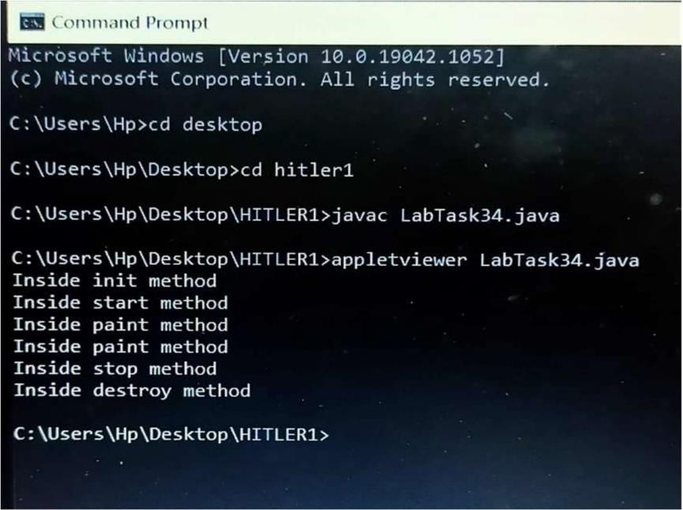

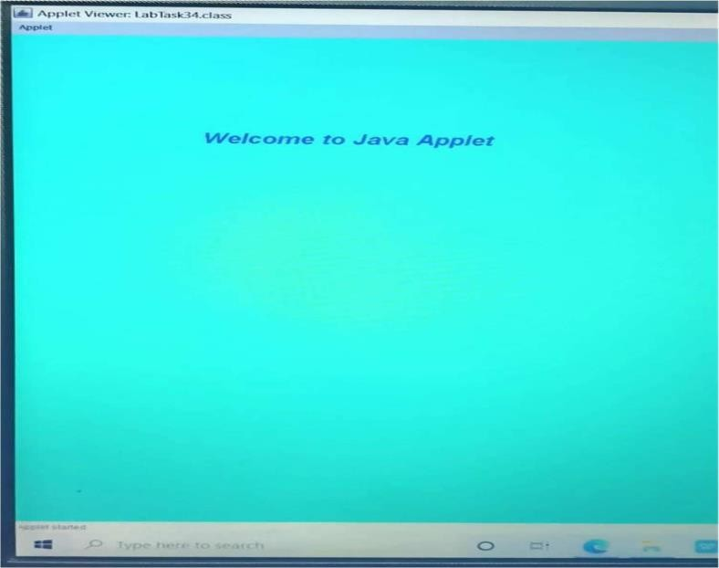

# LabTask:35

**AÏM : Write a JAVA program to design a laughing baby face.**

# PROGRAM:

//LabTask35.javaimport java.applet.*;importjava. awt.*;

/*<appletcode="LabTask35.class"width="600"height="800">

</applet>*/ publicclassLabTask35extendsApplet

{

publicvoidinit()

{

setBackground(Color.black);setForeground(Color.yellow);

}

publicvoidpaint(Graphicsg)

}

Fontf=newFont("Arial",1,28);g.setFont(f);

g.drawString("Folks!Ï'maLaughingBabyFace",340,550);g.dr awOval(75,460,40,40);

g.fillOval(75,460,40,40);g.drawLine(147,460,147,560); g.drawOval(175,460,40,40);g.fillOval(175,460,40,40);g. drawOval(20,400, 260,260);g.drawArc(80,535,135,80,180,180);

}

}

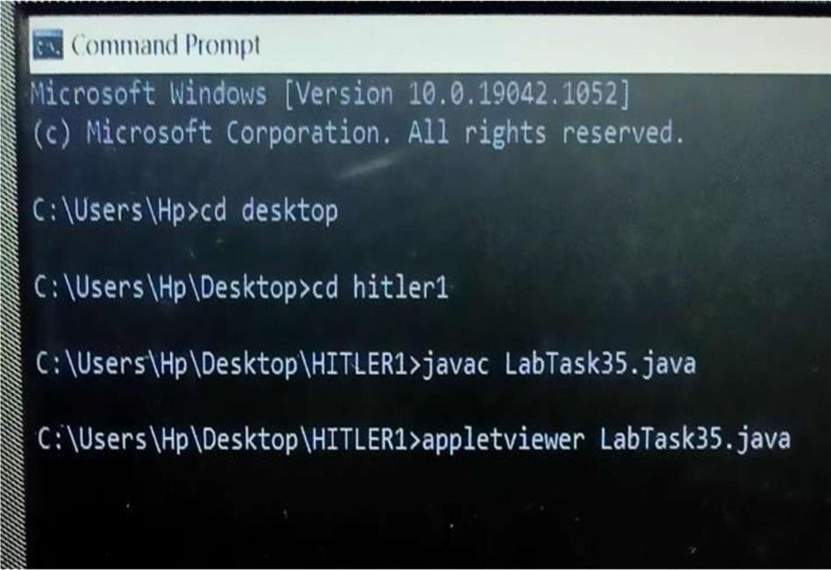

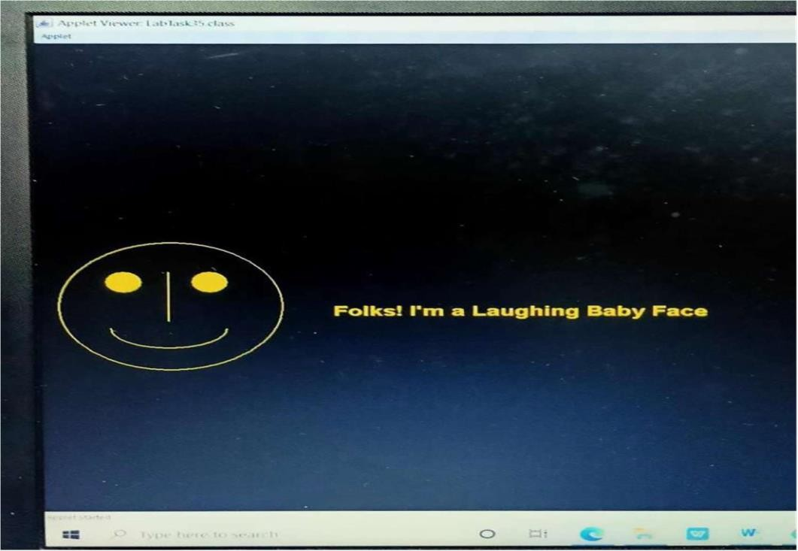

## LabTask:36

**AÏM: Write a JAVA program to create a simple calculator. PROGRAM:**

import java.awt.*; import java.awt.event.*;import java.applet.*;

/* <applet code="Calculator.class" width="700" height="200">

</applet>*/

public class Calculator extends Applet implements ActionListener { String msg = "";

TextField t1, t2, t3; Button b1, b2, b3, b4;Label l1, l2, l3; public void init() {

l1 = new Label("First Number"); add(l1);

t1 = new TextField(15); add(t1);

l2 = new Label("Second Number"); add(l2);

t2 = new TextField(15); add(t2);

l3 = new Label("Result"); add(l3);

t3 = new TextField(15); add(t3);

b1 = new Button("ADD"); add(b1); b1.addActionListener(this); b2 = new Button("SUB"); add(b2); b2.addActionListener(this); b3 = new Button("MULT"); add(b3); b3.addActionListener(this); b4 = new Button("DIV"); add(b4);

b4.addActionListener(this);

}

public void actionPerformed(ActionEvent e) { if (e.getSource() == b1) {

int x = Integer.parseInt(t1.getText()); int y = Integer.parseInt(t2.getText()); int sum = x + y;

t3.setText(" " + sum);

}

if (e.getSource() == b2) {

int x = Integer.parseInt(t1.getText()); int y = Integer.parseInt(t2.getText());

int sub = x - y; t3.setText(" " + sub);

}

if (e.getSource() == b3) {

int x = Integer.parseInt(t1.getText());

int y = Integer.parseInt(t2.getText()); int mul = x * y;

t3.setText(" " + mul);

}

if (e.getSource() == b4) {

int x = Integer.parseInt(t1.getText());

int y = Integer.parseInt(t2.getText()); int div = x / y;

t3.setText(" " + div);

}

if (e.getSource() == b4) {

int x = Integer.parseInt(t1.getText()); int y = Integer.parseInt(t2.getText()); int div = x / y;

t3.setText(" " + div);

}

showStatus(" text & button example"); repaint();

}

}

